EX NO:03
DATE:
GLOBAL SUPERSTORE CHART CREATION
AIM: To create and analyze Pareto, Funnel, Waterfall, and Control charts using the Global Superstore 2016 dataset in Tableau to understand profit distribution, potential revenue at different stages, changes in sales over time, and variations in performance using control limits.

- Draw a Pareto Chart for Running total of sum of profit. Use the dataset global superstore 2016
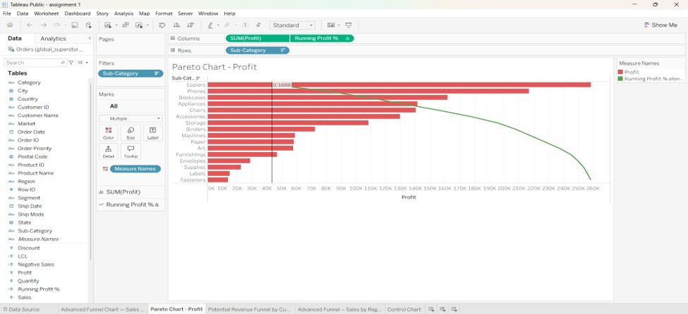
INTERPRETATION: The Pareto chart displays profit distribution across different categories or sub-categories, along with the cumulative running total of profit. It helps identify the products that contribute most significantly to the overall profit. This analysis allows the business to focus on high-profit products and improve the performance of less profitable products.

- How funnel chart shows the amount of potential revenue for each stage? – Discuss briefly. Use the dataset global superstore 2016
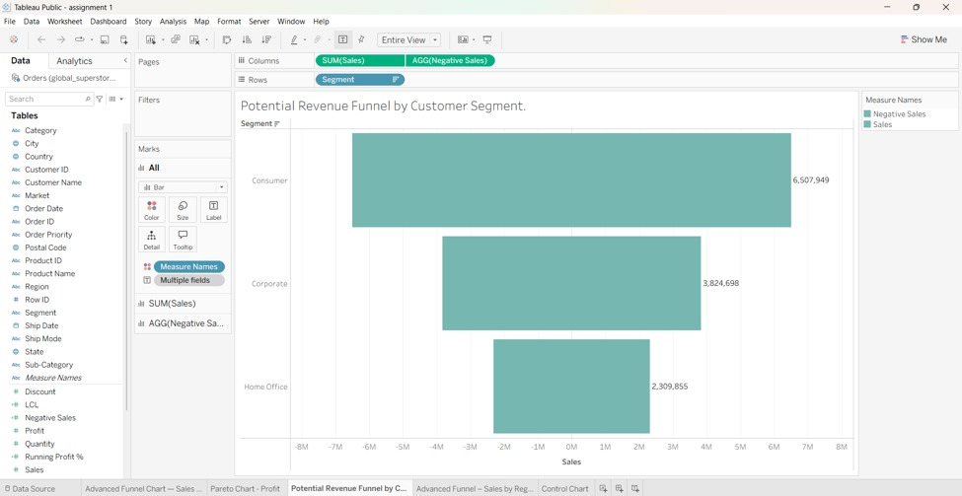
INTERPRETATION: The funnel chart represents the potential revenue at different stages of the sales process. It helps identify how revenue changes as opportunities move from one stage to the next and highlights stages where potential revenue decreases. This analysis helps management identify weak points in the sales process and develop strategies to improve sales conversion.

- Draw a Waterfall Chart show how the sales start, end and gets incremented over a period of time. Use the dataset global superstore 2016
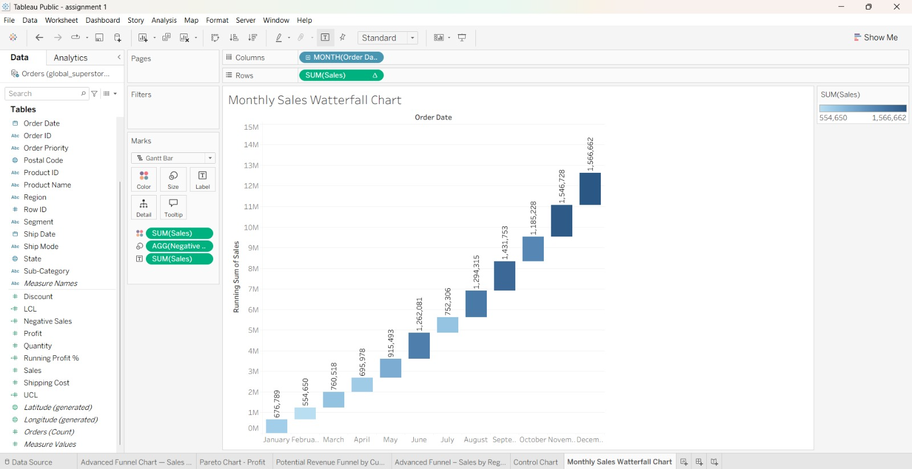
INTERPRETATION: The waterfall chart illustrates how sales start, increase, or decrease over a period and arrive at the final sales value. It highlights the contribution of individual periods to the overall change in sales. This visualization helps identify periods of sales growth or decline and supports better sales planning and decision-making.

- Creates a control chart and sets up a parameter to determine control limits. Use the dataset global superstore 2016
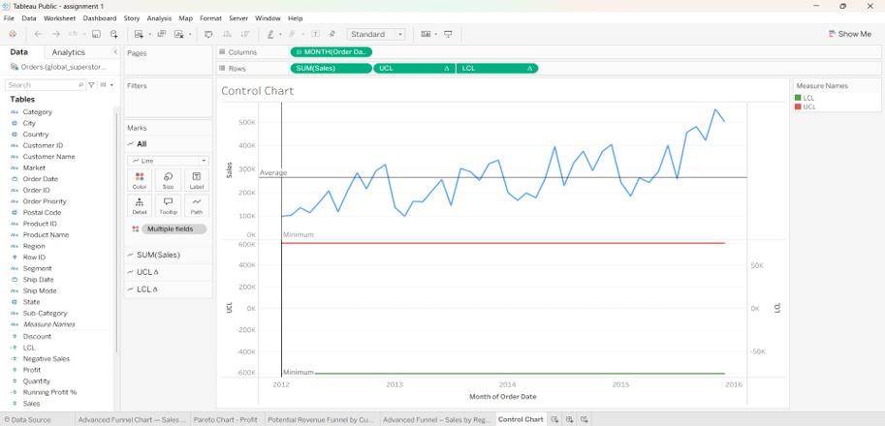
INTERPRETATION: The control chart monitors changes in performance over time using a central line and upper and lower control limits. A parameter allows users to adjust the control limits according to the selected number of standard deviations. The chart helps identify unusual variations, potential outliers, and periods that may require further investigation, supporting better monitoring of business performance.

